Original Research Article

Technology Acceptance and Institutional Trust in Smart City Development: An Empirical Study of Shanghai’s Positioning in International City Marketing

Huaoxuan Xu¹, Jianquan Guo¹*
¹Sino German College, University of Shanghai for Science and Technology, Shanghai 200093, P. R. China

*Corresponding Author: Jianquan Guo
Sino German College, University of Shanghai for Science and Technology, Shanghai 200093, P. R. China

Article History
Received: 06.04.2026
Accepted: 23.05.2026
Published: 27.05.2026

Abstract: This paper examines the perception of smart city services in Shanghai in the context of international city marketing. The main objective is to analyze how digital urban technologies are accepted by users and which factors play a central role in this process. The study is based on survey data collected in March 2026 and analyzed with Excel. After data cleaning, the analysis focuses on respondents who are familiar with the concept of smart cities and currently live in Shanghai or the greater Shanghai area. The theoretical framework combines the Technology Acceptance Model (TAM), the Product, Price, Place, and Promotion (4P) model, the Segmentation, Targeting, and Positioning (STP) strategy, and a Strengths, Weaknesses, Opportunities, and Threats (SWOT) analysis. These models help to explain both user acceptance and the strategic positioning of Shanghai as a global smart city. The results show that Shanghai is perceived very positively in several smart city dimensions, especially in Smart People, Smart Mobility, Smart Economy, Smart Governance, Smart Environment, and Smart Living. The findings suggest that perceived usefulness, daily convenience, institutional trust, and system integration are key factors behind the high acceptance of smart city services. At the same time, the study also shows that high acceptance does not necessarily mean that all potential risks are fully reflected by users. Issues such as data privacy, transparency, and public participation remain important challenges for the long-term development of smart cities. Overall, Shanghai can be seen as a strong example of how digital technologies, urban governance, and city branding can be combined in international city marketing.
Keywords: Smart City, Shanghai, International Marketing, City Branding, Technology Acceptance, Digital Governance.

1. INTRODUCTION
In recent years, smart city development has become an important topic in urban studies, public governance, and international city marketing. A smart city is not only characterized by digital infrastructure, but also by the interaction between technology, people, institutions, and urban services (Nam & Pardo, 2011; Albino et al., 2015). As cities face increasing pressure from population growth, mobility demand, environmental challenges, and global competition, digital technologies are often used to improve urban efficiency and public service delivery (Caragliu et al., 2011; Angelidou, 2014).

From the perspective of international marketing, cities today do not compete only through economic size or physical infrastructure. They also compete through innovation capacity, digital services, quality of life, public image, and the experience they offer to residents, companies, investors, and visitors (Kavaratzis, 2004; Braun et al., 2013). In this sense, a city can be understood not only as a geographical space, but also as a brand that needs to communicate its identity and competitive advantages (Zenker et al., 2017). Smart city development can therefore become part of city branding, because digital services make modernization and efficiency visible in everyday urban life (Harrison et al., 2010; Deakin & Al Waer, 2011).

Shanghai is a relevant case for this topic because it is one of China’s most important economic centers and has developed a highly digitalized urban environment. Previous studies have discussed Shanghai as an important case of smart mega-city development in China, especially because of its strong infrastructure, economic scale, and integration of digital urban services (Cui et al., 2023). In daily life, digital services such as mobile payment, transportation apps, online public services, smart retail platforms, and digital governance systems are widely used in Shanghai. These services make smart city development visible not only as a policy concept, but also as a practical experience for ordinary users.

However, the success of a smart city cannot be evaluated only by the existence of digital systems. Smart city development also depends on how users perceive and accept these systems (Davis, 1989; Venkatesh et al., 2003). According to the Technology Acceptance Model (TAM), users are more likely to accept a technology when they perceive it as useful and easy to use. In the context of smart cities, this means that digital services are more likely to be accepted when they provide clear practical benefits, such as saving time, reducing effort, improving mobility, or making public services more convenient.

At the same time, smart city acceptance is not only a technological issue. Many smart city services are connected with public institutions, data-based governance, and the use of personal or behavioral data (Bélanger & Carter, 2008; Gil-Garcia et al., 2015). This makes institutional trust an important factor. If users trust the institutions behind digital systems, they may perceive lower risks and become more willing to use digital public services. If trust is weak, even technically advanced services may face resistance or criticism.

This point is especially important in the case of Shanghai. On the one hand, Shanghai’s smart city services can create a strong impression of convenience, efficiency, and modernization. On the other hand, data-driven urban systems may also raise questions about privacy, transparency, and individual control (Kitchin, 2014; van Zoonen, 2016). Therefore, Shanghai provides a useful case for analyzing both the positive acceptance of smart city services and the critical issues behind this acceptance.

Against this background, the central research question of this paper is:
Which factors influence the acceptance of smart city services in Shanghai?
To answer this question, the paper focuses mainly on two aspects: perceived usefulness and trust in public institutions. Perceived usefulness is selected because it is one of the core factors in the Technology Acceptance Model and is directly related to users’ daily experience of digital services. Institutional trust is selected because many smart city services are embedded in public governance, digital administration, and data-based urban management.

This paper combines theoretical discussion with empirical analysis. The theoretical part draws on the Technology Acceptance Model (TAM), the Product, Price, Place, and Promotion (4P) model, the Segmentation, Targeting, and Positioning (STP) strategy, and a Strengths, Weaknesses, Opportunities, and Threats (SWOT) analysis. These models make it possible to examine smart city acceptance from both the user perspective and the city marketing perspective (Kotler et al., 2022; Pike, 2008). The empirical part is based on survey data collected in March 2026. After data cleaning, the analysis focuses on respondents who are familiar with the concept of smart cities and live in Shanghai or the greater Shanghai area.

The paper is structured as follows. First, the theoretical background is introduced, including smart city development, international city marketing, standardization and adaptation, the Product, Price, Place, and Promotion (4P) model, the Segmentation, Targeting, and Positioning (STP) strategy, technology acceptance, institutional trust, and Shanghai’s smart city positioning. At the end of the theoretical section, the research hypotheses are developed based on the literature. Then, the methodology and data basis are explained. After that, the survey results are presented and discussed. Finally, the paper derives marketing implications and concludes with a critical reflection on Shanghai’s smart city development.

2. LITERATURE REVIEW

2.1 Smart Cities in the Context of International Marketing
Smart city development is often discussed as a technological topic, but the concept is broader than digital infrastructure alone. A smart city is commonly understood as an urban system in which technology, people, institutions, and services interact with each other to improve urban life and city management (Chourabi et al., 2012; Batty et al., 2012). Therefore, smart city development should not be reduced to the number of sensors, platforms, or digital applications a city has. It also depends on how these technologies are experienced by users and how they are embedded in the social and institutional environment of the city.

From the perspective of international city marketing, smart city development is closely connected with image, positioning, and user perception. Cities increasingly compete not only through economic strength, but also through innovation capacity, quality of life, public services, and international reputation (Anholt, 2007; Hospers, 2011). In this sense, a city can be treated as a brand that communicates its identity and competitive advantages to different target groups, such as residents, companies, investors, tourists, and international professionals.

Smart city services can support city branding because they make modernization visible in everyday life. Digital transportation systems, online public services, smart retail platforms, and mobile applications can create the impression that a city is efficient, innovative, and future-oriented (Komninos, 2002; Dameri, 2013). However, this image is not created only by official communication. It is also shaped by repeated user experience. If residents experience digital systems as convenient, reliable, and easy to use, smart city development can strengthen the positive image of the city.

Shanghai fits this logic well. As a major economic and financial center, Shanghai has both the infrastructure and the market environment to support large-scale smart city development. Previous research has discussed Shanghai as a relevant case of smart mega-city development in China, especially because of its economic scale, urban complexity, and integration of digital services. In this context, Shanghai’s smart city development is not only a technical process, but also part of its international positioning as a modern, efficient, and globally connected city.

For this reason, user perception is especially important. A city may invest heavily in digital infrastructure, but the marketing value of these investments depends on whether users actually perceive them as useful and reliable. If smart city services improve daily life, they can strengthen Shanghai’s city image. If they are perceived as complicated, risky, or unclear, they may weaken trust and reduce acceptance. Therefore, smart city acceptance is not only a technological issue, but also a marketing and governance issue.

2.2 Standardization and Adaptation
A central issue in international marketing is the balance between standardization and adaptation. Standardization means that a product, service, or strategy is applied in a similar way across different markets, while adaptation means that it is adjusted to local conditions, user expectations, and institutional environments (Theodosiou & Leonidou, 2003; Vrontis, Thrassou, & Lamprianou, 2009). This question is also relevant for smart city services because many digital urban technologies appear technically similar across cities, but they may be perceived differently by users in different contexts.

From a technical perspective, many smart city solutions can be standardized. Digital platforms, sensors, traffic management systems, mobile applications, online public services, and data-based urban management tools often follow similar technological principles (Washburn et al., 2010; Zygiaris, 2013). Their general purpose is to improve efficiency, reduce uncertainty, optimize resource allocation, and make urban services easier to access. In this sense, the technical logic of smart city systems can be transferred from one city to another.

However, the social meaning of these technologies is not standardized. Users in different cities may evaluate the same technology in different ways depending on local culture, trust structures, privacy expectations, and public communication (Söderström, Paasche, & Klauser, 2014; Shelton, Zook, & Wiig, 2015). In some markets, users may focus mainly on speed, convenience, and efficiency. In other markets, they may pay more attention to data privacy, transparency, participation, and individual control. Therefore, a smart city system that is accepted in one place may face resistance in another.

Shanghai represents a context in which usefulness and efficiency are highly visible in daily life. Digital payment, transportation apps, online public services, and smart retail platforms have become part of everyday urban routines. As a result, users may evaluate these systems mainly through practical questions: Does the system save time? Is it convenient? Does it reduce effort? Does it make urban life easier? This practical orientation is closely related to technology acceptance theory, which emphasizes perceived usefulness and ease of use as key factors influencing acceptance.

At the same time, privacy and transparency cannot be ignored. Data-driven urban systems can improve city management, but they also raise questions about how data are collected, processed, shared, and governed (Cardullo & Kitchin, 2019; Zuboff, 2019). Therefore, international smart city marketing should not treat smart city solutions only as technical products. It should also consider local user habits, institutional trust, privacy expectations, and communication strategies. In this sense, smart city services require technical standardization and social adaptation at the same time.

2.3 The Product, Price, Place, and Promotion (4P) Model and Smart City Services
The Product, Price, Place, and Promotion (4P) model is one of the classical frameworks in marketing analysis (McCarthy, 1960; Kotler & Keller, 2016). Although it was originally developed for business marketing, it can also be applied to cities and public services when cities are understood as competitive and communicative entities. In the context of smart cities, the 4P model helps explain how digital urban services create value, how users access them, and how they contribute to city image.

In the smart city context, Product refers not only to physical goods, but also to digital urban services and integrated user experiences. Examples include transportation apps, digital payment systems, online government services, smart retail platforms, and data-based management systems. These services correspond to the broader understanding of smart cities as systems that combine technology, people, and institutions (Meijer & Bolívar, 2016; Gil-Garcia, Pardo, & Nam, 2015). In Shanghai, these services are often not experienced as isolated technologies. Instead, they form part of a connected digital lifestyle.

Price should also be understood in a broader sense. In traditional marketing, price usually refers to monetary cost. In smart city services, however, users may also pay with time, attention, personal data, or reduced control over private information (Lyon, 2014; van Dijck, 2014). In Shanghai, the perceived benefits of smart city services, such as convenience, speed, and efficiency, may make users more willing to accept these indirect costs. This reflects the logic of technology acceptance theory, which suggests that users are more likely to accept a technology when they perceive clear usefulness.

Place refers to the access point of a service. In smart cities, access is often digital rather than purely physical. Users can reach services through mobile applications, QR codes, online platforms, or integrated digital ecosystems. This changes the relationship between urban space and service delivery. The city is no longer accessed only through physical locations, but also through digital interfaces and data-based platforms (Graham & Marvin, 2001; Townsend, 2013). In Shanghai, the boundary between physical and digital space is often blurred because users move through the physical city while relying heavily on digital tools.

Promotion refers to communication and image building. Smart city services contribute to the image of Shanghai as a modern, efficient, and technologically advanced city. This is important because city branding is shaped not only by official slogans, but also by concrete urban experiences. If residents and visitors repeatedly experience digital services as useful and convenient, these experiences can support Shanghai’s smart city image.

The 4P model is therefore useful for this paper because it shows that smart city services can be analyzed as part of a broader marketing strategy. Shanghai does not only provide digital technologies; it also creates a certain user experience and urban image. This connection between service design, user perception, and city branding is central to understanding Shanghai’s smart city positioning in international marketing.

2.4 Segmentation, Targeting, and Positioning (STP) Strategy and Shanghai’s Positioning
The Segmentation, Targeting, and Positioning (STP) strategy consists of three steps: dividing a market into different groups, selecting the most relevant target groups, and positioning a product, service, or brand toward these groups. It is widely used in marketing to explain how organizations identify customer needs and build a clear market position (Smith, 1956; Hooley, Piercy, & Nicoulaud, 2012). In city marketing, STP can also be used to analyze how a city addresses different audiences and builds a clear image in the international market.

In terms of segmentation, Shanghai has several important target groups. These include local residents, domestic and international companies, investors, skilled workers, tourists, and international organizations. These groups have different expectations. Residents may care more about convenience, transportation, safety, and quality of life. Companies and investors may focus more on infrastructure, economic stability, innovation capacity, and business opportunities. This reflects the idea that city brands are not directed at only one homogeneous audience, but at multiple stakeholder groups with different needs (Merrilees, Miller, & Herington, 2012; Zenker & Beckmann, 2013).

In terms of targeting, Shanghai appears to focus strongly on groups that value efficiency, innovation, economic opportunity, and global connectivity. The city’s financial district, digital infrastructure, international events, and smart city services all support this orientation. Smart city development can therefore serve both residents and external target groups. For residents, it improves daily convenience. For companies and investors, it signals that Shanghai has advanced infrastructure and a strong digital business environment. This dual function is important for international city marketing.

In terms of positioning, Shanghai presents itself as modern, efficient, global, and technologically advanced. This image is supported not only by official communication, but also by daily digital experiences. When people use mobile payment, transportation apps, online public services, or smart retail platforms, they directly experience the city’s digital character. These experiences make the city’s positioning more concrete and credible.

However, positioning always involves selection. A city may emphasize technology, economic strength, and global competitiveness, while other issues such as housing pressure, inequality, environmental challenges, public participation, or privacy concerns receive less attention. Critical smart city research warns that smart city narratives can sometimes focus too strongly on efficiency and innovation while underestimating social and political questions (Greenfield, 2013; Wiig, 2015). Therefore, Shanghai’s smart city positioning should be understood both as a strength and as an issue that requires critical reflection.

The STP strategy is useful for this paper because it links smart city development with international city marketing. Shanghai’s digital services are not only functional tools; they also help define who the city wants to attract and how the city wants to be perceived. In this way, smart city development becomes part of Shanghai’s broader strategy of urban positioning and global competitiveness.

2.5 Technology Acceptance, Usefulness, and Trust
The Technology Acceptance Model (TAM) provides an important theoretical foundation for understanding why users accept or reject digital technologies. According to Davis (1989), perceived usefulness and perceived ease of use are two key factors influencing technology acceptance. Perceived usefulness refers to the degree to which users believe that a technology improves their performance or helps them achieve practical goals. Perceived ease of use refers to the degree to which users believe that a technology can be used without too much effort.

Later research further developed this idea. Instead of treating technology adoption as a purely individual decision, later acceptance models show that user behavior is also influenced by social expectations, available support, system quality, and the actual conditions under which a technology is used (Venkatesh et al., 2003; Venkatesh, Thong, & Xu, 2012). This means that users do not evaluate technologies only as isolated tools. Their acceptance is also shaped by social context, available support, and whether the technology fits into their daily routines. In the case of smart cities, this is especially relevant because digital services are often used repeatedly in everyday life.

In Shanghai, perceived usefulness is particularly important. Many smart city services provide clear daily benefits. Transportation apps can reduce uncertainty in travel, mobile payment can make transactions faster, online public services can reduce waiting time, and smart retail platforms can connect shopping, payment, and delivery. These benefits are directly connected with users’ daily experience. According to the logic of TAM, such visible usefulness can increase users’ willingness to accept and continue using digital services.

Ease of use is also relevant. If digital services are simple, reliable, and easily accessible, they can become part of everyday routines. Once users become familiar with these systems, they may no longer perceive them as “new technologies,” but as normal tools of urban life. This process strengthens acceptance over time. It also explains why smart city services in Shanghai may be evaluated positively when they are deeply integrated into daily routines.

However, smart city acceptance cannot be explained by usefulness and ease of use alone. Many smart city services are connected with public institutions, urban data systems, and digital governance. Therefore, trust becomes an important factor (Mayer, Davis, & Schoorman, 1995; Bélanger & Carter, 2008). Users may need to provide information, use official platforms, or rely on digital public services. In these situations, acceptance depends not only on whether the service is useful, but also on whether users trust the institutions behind the system.

This is particularly relevant for Smart Governance. If users believe that public institutions are reliable and that digital systems are used responsibly, they may perceive lower risks and become more willing to use digital services. If trust is weak, even technically useful services may be questioned. At the same time, data-driven urban systems may raise concerns about privacy, surveillance, transparency, and individual control (Lyon, 2014; Cardullo & Kitchin, 2019). Therefore, this paper treats perceived usefulness and institutional trust as two central factors in the acceptance of smart city services in Shanghai.

2.6 Strengths, Weaknesses, Opportunities, and Threats (SWOT) Analysis of Shanghai as a Smart City
A Strengths, Weaknesses, Opportunities, and Threats (SWOT) analysis helps to identify the strengths, weaknesses, opportunities, and threats of Shanghai’s smart city development. This approach is useful because smart city success depends not only on technology, but also on economic conditions, infrastructure, user acceptance, institutional capacity, and social risks (Gürel & Tat, 2017; Lombardi et al., 2012).

Shanghai has several strengths as a smart city. First, it has a strong economic foundation. As one of China’s most important financial and business centers, Shanghai has the resources and market conditions to support digital innovation and large-scale urban transformation. Second, the city has advanced infrastructure, including a large metro system, major airports, high-speed railway connections, and a well-developed digital service environment. These conditions make it easier to implement and expand smart city systems (Cui et al., 2023; Mora, Bolici, & Deakin, 2017).

Another strength is the high visibility of digital services in daily life. In Shanghai, smart city development is not only an abstract policy goal. It can be experienced through transportation, payment, shopping, public services, and urban management. This everyday visibility helps users recognize the practical value of digital systems. It also supports the city’s image as modern and efficient, which is important for international city marketing.

At the same time, Shanghai also faces weaknesses. The city has a very large population and high population density. This creates pressure on transportation, housing, public services, and the environment. High living costs and housing prices can also increase social inequality. These problems show that digital development alone cannot solve all urban challenges. Critical smart city studies also point out that technology-based urban strategies may improve efficiency, but they do not automatically solve deeper social, spatial, or governance problems (Datta, 2015; Marvin, Luque-Ayala, & McFarlane, 2016).

Shanghai also has strong opportunities. Smart city technologies can improve traffic management, public service delivery, environmental monitoring, and urban efficiency. They can also support Shanghai’s international image as a modern and innovative city. In this way, smart city development can strengthen both urban management and city marketing. More broadly, smart city initiatives can improve urban competitiveness when they are connected with innovation, infrastructure, human capital, and governance capacity.

However, there are also risks. One risk is international competition. Other global cities, such as Singapore, Tokyo, Seoul, London, and New York, also use technology to improve their global positioning. Another risk concerns data privacy and transparency. Smart city systems rely on large amounts of data. If users become more concerned about how their data are collected and used, acceptance may become more fragile (Kitchin, Lauriault, & McArdle, 2015; Taylor, 2016). This is important because the long-term success of smart city development depends not only on technical performance, but also on trust, legitimacy, and social acceptance.

Overall, the SWOT analysis shows that Shanghai has strong foundations for smart city development, but also faces long-term challenges. Its success depends not only on technological progress, but also on whether digital systems can remain useful, trusted, transparent, and socially acceptable. This connects Shanghai’s smart city development with both technology acceptance and international city marketing.

2.7 Hypotheses Development
Based on the theoretical discussion above, this paper develops two research hypotheses. These hypotheses connect the literature on technology acceptance, institutional trust, and smart city development with the empirical analysis of Shanghai.

The first hypothesis is related to perceived usefulness. According to the Technology Acceptance Model, perceived usefulness is one of the most important factors influencing whether users accept a new technology (Davis, 1989). Later research on technology acceptance also shows that users are more likely to adopt a technology when they believe that it improves performance, reduces effort, or provides practical benefits (Venkatesh et al., 2003). In the context of smart cities, usefulness is especially important because many digital urban services are used in everyday situations, such as transportation, payment, shopping, public administration, and information access.

For Shanghai, perceived usefulness can be observed in several areas. Digital mobility services can help users plan routes more efficiently and reduce uncertainty in daily travel. Mobile payment and smart retail platforms can make consumption faster and more convenient. Online public services can reduce waiting time and make administrative processes easier. These examples show that smart city technologies are not only abstract technical systems, but also practical tools that influence daily urban life.

This is relevant for international city marketing because user experience can shape the image of a city. If digital services are perceived as useful, users may also perceive the city itself as more efficient, modern, and well organized (Kavaratzis, 2004; Albino et al., 2015). Therefore, perceived usefulness is expected to increase the acceptance of smart city services in Shanghai.

H1: The higher the perceived usefulness of smart city services, the higher the acceptance of these services in Shanghai.

The second hypothesis is related to institutional trust. Smart city services are often not purely private or commercial services. Many of them are connected with public institutions, digital governance, urban data platforms, and public service systems. This means that users do not only evaluate the technology itself. They also evaluate the institutions behind the technology.

Trust is important because smart city services often involve data collection, platform-based interaction, and digital decision-making. Data-driven urban systems can improve efficiency, but they may also raise concerns about privacy, surveillance, transparency, and individual control (Kitchin, 2014; Hollands, 2008). If users trust public institutions, they may perceive these risks as more manageable. If trust is weak, users may become more skeptical toward digital governance systems, even when the systems are technically useful.

In the case of Shanghai, institutional trust is particularly relevant because many smart city services are embedded in public governance and urban management. Digital public services, smart governance platforms, and data-based city management systems depend not only on technological performance, but also on users’ willingness to rely on public institutions. Therefore, trust in public institutions is expected to have a positive influence on the acceptance of digital smart city technologies.

H2: Trust in public institutions has a positive influence on the acceptance of digital smart city technologies.

Together, these two hypotheses reflect two different but connected dimensions of smart city acceptance. H1 focuses on the practical benefits that users experience in daily life, while H2 focuses on the institutional environment in which smart city services are provided. In Shanghai, these two factors may work together. Digital services are accepted not only because they are useful, but also because they are embedded in a relatively strong system of urban governance and public service provision. This combination is important for understanding Shanghai’s smart city development and its positioning in international city marketing.

3. METHODOLOGY
This paper uses survey data collected in March 2026 to analyze the perception of Shanghai as a smart city. The survey includes questions about different smart city dimensions, the use of digital public services, attitudes toward data use, trust in institutions, and privacy concerns.

Before the analysis, the data were cleaned to make the results more reliable. Since this paper focuses on Shanghai, only respondents who live in Shanghai or the greater Shanghai area were included. In addition, respondents who were not familiar with the concept of smart cities were excluded. After this filtering process, the final sample consisted of 53 valid respondents.

The data were analyzed with Excel. The analysis mainly uses descriptive statistics, percentage distributions, and mean-value indices. These methods are suitable for this paper because the aim is not to build a complex statistical model, but to identify general patterns in how respondents perceive smart city services in Shanghai.

The survey evaluates six smart city dimensions: Smart People, Smart Mobility, Smart Economy, Smart Governance, Smart Environment, and Smart Living. These dimensions were selected because they cover both technological and social aspects of smart city development. Smart Mobility and Smart Living are closely connected with daily life, while Smart Governance is more related to public institutions and trust.

The evaluation scale ranges from 1 to 4. A lower value represents a more positive evaluation. Therefore, a lower mean-value index indicates that a dimension is perceived as more advanced.

It is important to note that the data reflect subjective perceptions. They do not measure the objective technical performance of Shanghai’s smart city systems. Instead, they show how respondents experience and evaluate these systems. This is relevant because smart city acceptance depends not only on technical quality, but also on user perception, daily experience, and trust.

The sample size is limited, so the results cannot be seen as fully representative of the entire population of Shanghai. However, the data still provide useful insights into the attitudes of Shanghai-based respondents who are familiar with smart city development.

4. RESULTS
This section presents the empirical results of the survey. The analysis focuses on the cleaned sample of respondents who live in Shanghai or the greater Shanghai area and are familiar with the concept of smart cities. The final sample consists of 53 valid respondents. The results show that Shanghai is evaluated positively across all six smart city dimensions. Since lower index values represent better evaluations, the results indicate that respondents generally perceive Shanghai as an advanced smart city.

Figure 1 provides an overview of respondents’ evaluations of the six smart city dimensions. The chart shows that the majority of respondents rate Shanghai as either “very advanced” or “advanced” in all six dimensions. This suggests that Shanghai’s smart city development is perceived positively not only in one specific field, but across several areas of urban life.

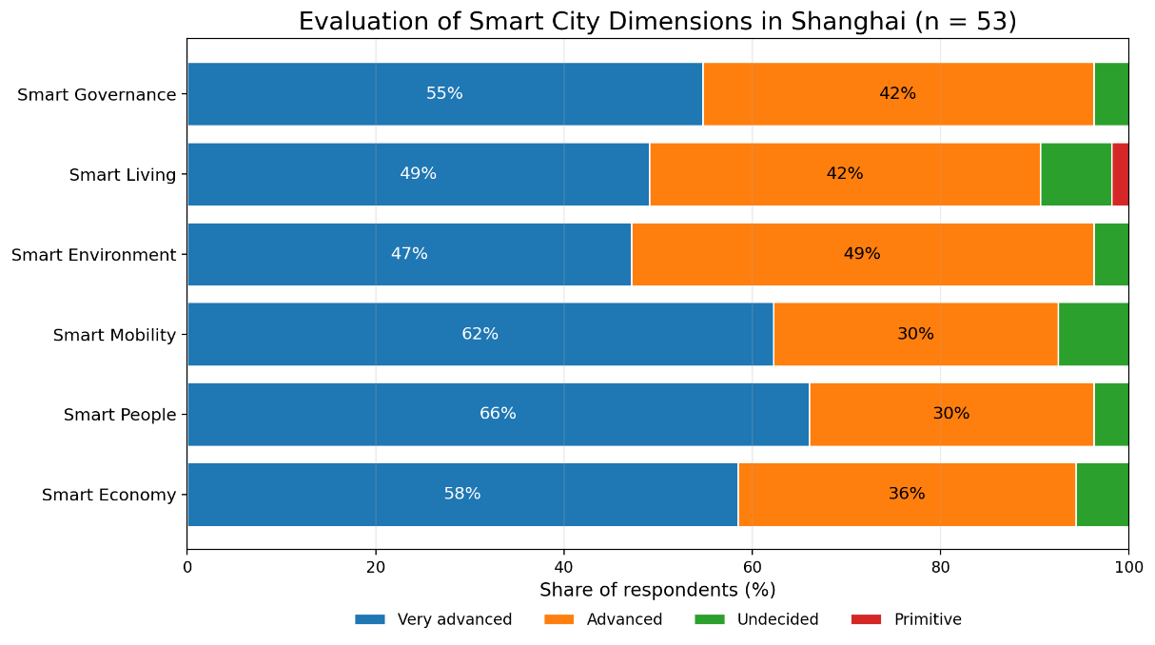

Figure 1: Evaluation of Smart City Dimensions in Shanghai
Note: The figure is based on the cleaned sample of Shanghai-based respondents who are familiar with the concept of smart cities (n = 53). Percentages show the share of respondents in each evaluation category.

Among the six dimensions, Smart People receive the best evaluation, with a mean index of 1.38. This suggests that respondents have a positive view of Shanghai’s human and social environment in relation to smart city development. It may indicate that people in Shanghai are seen as relatively open to digital services and capable of using new technologies in daily life.

Smart Mobility also receives a strong evaluation, with a mean index of 1.45. This result is important because mobility is one of the most visible areas of smart city development. Transportation apps, real-time information, digital ticketing, and mobile payment are directly connected with everyday urban experience. When these systems work well, users can immediately feel the benefits. This supports the idea that perceived usefulness is an important factor in smart city acceptance.

Smart Economy has a mean index of 1.47. This result reflects Shanghai’s strong economic and digital business environment. Respondents seem to connect the city’s smart development with innovation, digital consumption, and economic competitiveness. This is also relevant for international city marketing, because a smart economy can strengthen Shanghai’s image as a global business center.

Smart Governance receives a mean index of 1.49. This is particularly relevant for the second hypothesis of this paper. Digital governance systems are closely related to public institutions. The positive evaluation suggests that respondents generally perceive digital public services as reliable and useful. This can be interpreted as an indication that institutional trust supports the acceptance of smart city technologies in Shanghai.

Smart Environment receives a mean index of 1.57. Although this is still a positive result, it is slightly weaker than the scores for Smart People, Smart Mobility, Smart Economy, and Smart Governance. One possible explanation is that environmental improvements are less directly visible to users than mobility or digital services. Users may experience transportation apps or mobile payment every day, while environmental management is often less obvious in daily routines.

Smart Living receives the weakest index among the six dimensions, with a mean value of 1.62. However, this result is still positive. Smart Living is a broad dimension that includes quality of life, convenience, safety, housing, health, and daily services. Because it covers many different aspects, respondents may evaluate it less clearly than more specific areas such as mobility or governance.

Figure 2 summarizes these differences through a mean-value index. Since lower values indicate a more positive evaluation, the figure shows that all six dimensions are assessed at a relatively advanced level. The small difference between the highest and lowest index values also suggests that respondents may perceive Shanghai’s smart city development as an integrated system rather than as separate parts.

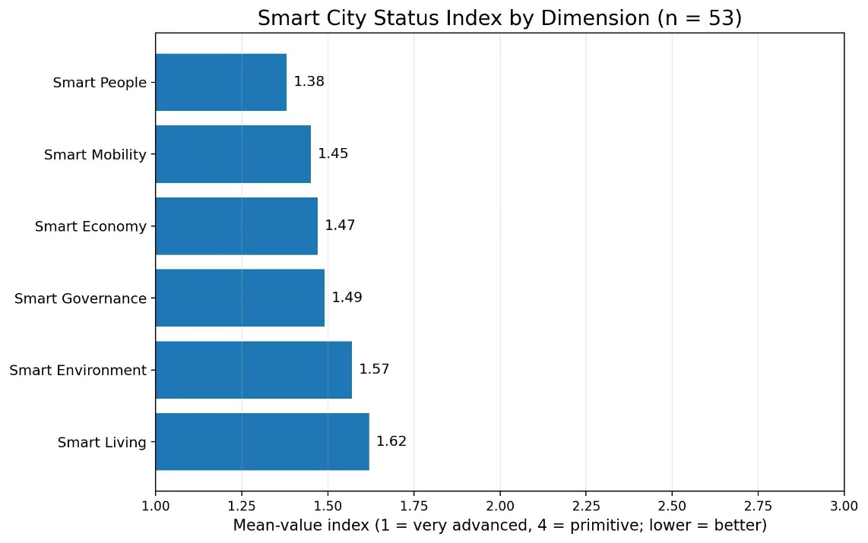

Figure 2: Smart City Status Index by Dimension
Note: The index is calculated on a scale from 1 to 4, where 1 means “very advanced” and 4 means “primitive.” Lower values therefore indicate a more positive evaluation.

The differences between the dimensions are not very large. This suggests that respondents may perceive Shanghai’s smart city development as an integrated system rather than as separate parts. Digital services in transportation, consumption, public administration, and daily life are often connected. For users, this creates a general impression of Shanghai as a digital and efficient city. The results also show that digital public services are used relatively frequently. This is important because acceptance is not only about positive attitudes. It is also connected with actual use.

As shown in Figure 3, most respondents use digital public services either daily or one to two times per week. This indicates that digital public services are not only recognized by respondents, but also regularly used in everyday life. Therefore, smart city technologies in Shanghai can be understood as practical tools that have already become part of normal urban routines.

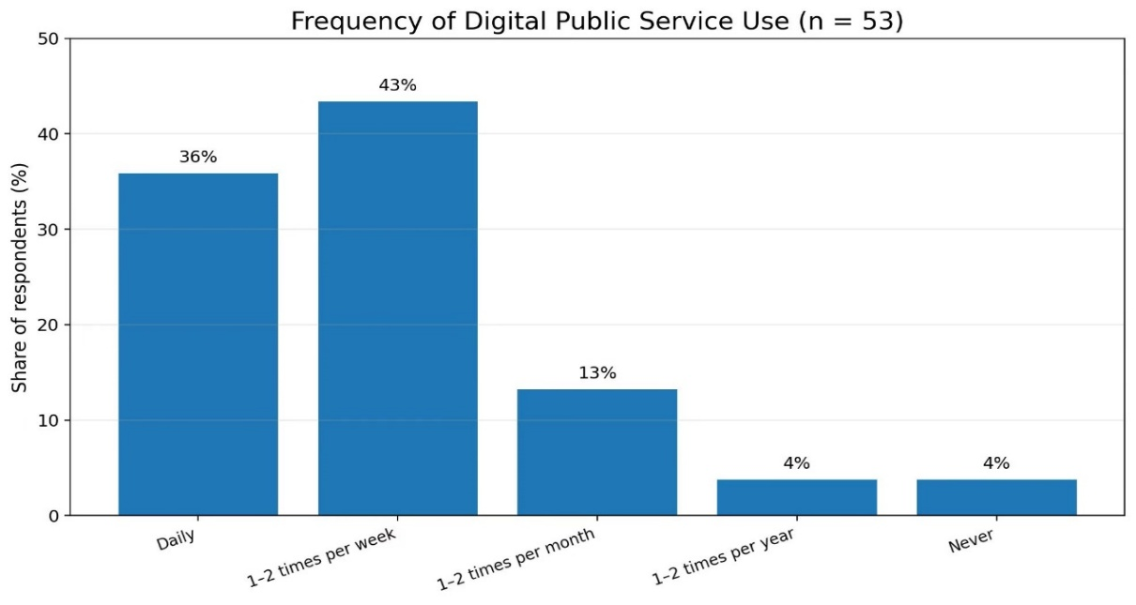

Figure 3: Frequency of Digital Public Service Use
Note: The figure shows how often respondents use digital public services in daily life. The results are based on the cleaned Shanghai sample (n = 53).
The findings related to data use and institutional trust also support the main argument of this paper. Many respondents show acceptance toward data-based smart city services, especially when these services provide visible benefits.

Figure 4 presents respondents’ attitudes toward data use, facial recognition, and online transparency. The results show a relatively high level of agreement, especially regarding the acceptance of facial recognition and the idea that online transparency can strengthen trust. This supports the argument that institutional trust plays an important role in the acceptance of digital smart city technologies.

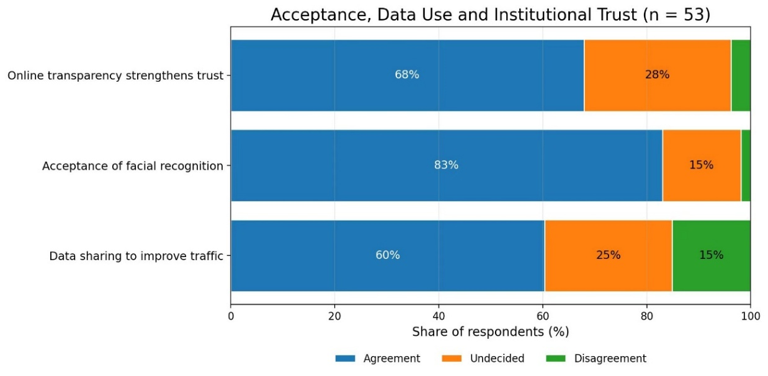

Figure 4: Acceptance, Data Use and Institutional Trust
Note: “Agreement” combines positive responses toward the statement, while “Disagreement” combines negative responses. The figure is used to show the general tendency of respondents’ attitudes toward data-based smart city services and institutional trust.

At the same time, trust in institutions remains important. Users are more willing to accept digital systems when they believe that the organizations behind them are reliable. However, privacy concerns still exist. Some respondents worry that smart city technologies may reduce personal privacy.

Figure 5 shows that a large share of respondents are at least somewhat concerned about reduced privacy caused by smart city technologies. This finding is important because it shows that high acceptance of digital services does not mean that users ignore potential risks. Instead, convenience and concern may exist at the same time.

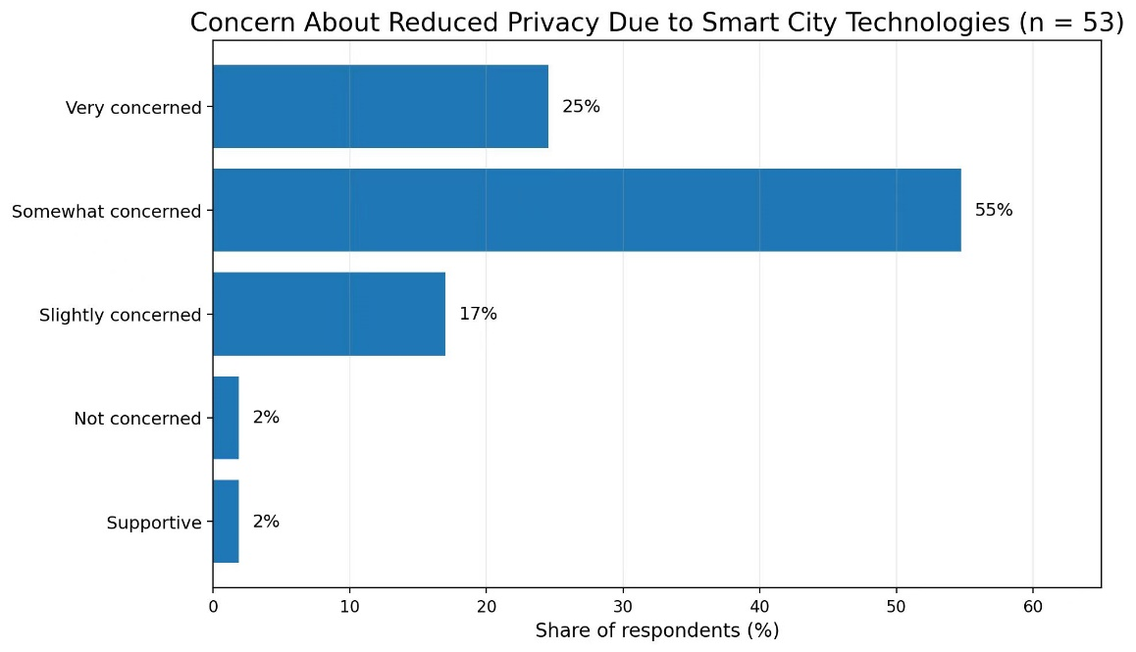

Figure 5. Concern About Reduced Privacy Due to Smart City Technologies
Note: The figure presents respondents’ level of concern about privacy reduction in the context of smart city technologies. It highlights the tension between digital convenience and privacy protection.
This means that the high acceptance of digital services does not remove the need for transparency and responsible data governance. Overall, the results provide preliminary support for both hypotheses. H1 is supported because the positive evaluations of smart city services are closely connected with visible usefulness in daily life. The strong evaluation of Smart Mobility and the frequent use of digital public services show that practical benefits are important for acceptance. H2 is also supported because the positive evaluation of Smart Governance and the relatively high level of agreement in Figure 4 suggest that institutional trust helps increase the acceptance of digital smart city technologies. At the same time, the results also show that acceptance should not be understood as the absence of concern. The privacy-related findings indicate that respondents may value convenience and efficiency, while still being aware of possible risks. This tension between usefulness, trust, and privacy will be discussed further in the following section.

5. DISCUSSION
The results of the survey show that Shanghai is generally perceived as an advanced smart city. However, the meaning of these results becomes clearer only when they are connected with user behavior, institutional trust, and international city marketing. Therefore, this section discusses the findings in four steps. First, it analyzes the main patterns in the Shanghai data. Second, it connects the results with the Technology Acceptance Model. Third, it discusses the role of institutional trust and smart governance. Finally, it reflects on the implications and limitations of Shanghai’s smart city model.

5.1 Main Patterns in the Shanghai Data
The first important pattern is that all six smart city dimensions receive positive evaluations. Smart People, Smart Mobility, Smart Economy, Smart Governance, Smart Environment, and Smart Living are all rated at a relatively advanced level. This suggests that respondents do not perceive Shanghai’s smart city development as limited to one specific area. Instead, they seem to experience it as a broader urban system.

This is important because smart city development is often difficult for users to observe as a whole. Ordinary residents may not directly see urban data platforms, government planning systems, or digital infrastructure. However, they can experience the effects of these systems through daily services, such as mobile payment, transportation apps, online public services, smart retail, and digital information systems. In this sense, Shanghai’s smart city image is built through everyday contact with digital services.

The second important pattern is that the differences between the six dimensions are relatively small. This indicates that respondents may not clearly separate one smart city dimension from another. For example, Smart Mobility, Smart Governance, and Smart Living may be experienced together in daily life. A user may plan a route through an app, pay digitally, receive public service information online, and use platform-based services during the same day. These experiences are connected rather than isolated.

This integrated experience is one of Shanghai’s strengths. It creates the impression that the city functions as a digital ecosystem. For international city marketing, this is valuable because a city brand is not built only through official slogans or promotional campaigns. It is also built through repeated user experiences. If people experience the city as convenient, fast, and efficient, this strengthens Shanghai’s image as a modern smart city.

At the same time, the slightly different scores between the dimensions are also meaningful. Smart People, Smart Mobility, Smart Economy, and Smart Governance are evaluated slightly better than Smart Environment and Smart Living. This suggests that respondents may find digitalization more visible in areas such as mobility, economy, and public services, while improvements in environmental quality or general living conditions are less direct or harder to judge.

This difference is important because it shows that smart city acceptance depends strongly on visibility. When a service produces immediate and practical benefits, users are more likely to evaluate it positively. When the benefit is indirect, long-term, or difficult to observe, the evaluation may be slightly weaker.

5.2 Perceived Usefulness and Technology Acceptance
The findings strongly support the first hypothesis of this paper:
H1: The higher the perceived usefulness of smart city services, the higher the acceptance of these services in Shanghai.

This hypothesis is based on the Technology Acceptance Model. According to this model, people are more likely to accept a technology when they believe that it is useful and when it helps them solve practical problems. The Shanghai data fit this logic well.

Smart Mobility is a clear example. Mobility is one of the most visible parts of urban life. Traffic, commuting time, route planning, and access to public transportation affect people almost every day. If digital mobility services help users save time, reduce uncertainty, or make transportation more convenient, the usefulness of these technologies becomes immediately visible.

This direct experience helps explain the positive evaluation of Smart Mobility. Users do not need to understand the technical system behind a transportation app or a traffic management platform. What matters to them is the practical result: whether the system makes movement through the city easier.

The same logic can also be applied to mobile payment, smart retail, and online public services. These services are accepted because they reduce effort in everyday life. For example, mobile payment makes transactions faster, online public services reduce the need to visit offices in person, and smart retail platforms combine shopping, payment, and delivery. In each case, technology is accepted because it creates practical convenience.

This also explains why smart city technologies in Shanghai are often not perceived as separate innovations anymore. Many of them have already become part of normal daily routines. Once a digital service becomes habitual, users may stop thinking about it as “technology.” It becomes part of the expected urban environment.

Therefore, perceived usefulness in Shanghai is not abstract. It is experienced through time saving, convenience, efficiency, and reduced uncertainty. These factors help explain why respondents generally evaluate Shanghai’s smart city development positively.

However, this also shows a limitation of technology acceptance. When users focus strongly on usefulness, they may pay less attention to hidden costs, such as data collection or reduced privacy. This does not mean that users do not care about privacy. Rather, it means that immediate usefulness can sometimes be more visible than long-term risks.

5.3 Institutional Trust and Smart Governance
The second hypothesis of this paper is also supported by the findings:
H2: Trust in public institutions has a positive influence on the acceptance of digital smart city technologies.

This hypothesis is especially relevant for the dimension of Smart Governance. In the survey results, Smart Governance receives a positive evaluation. This suggests that respondents generally accept digital public services and governance-related smart city systems in Shanghai.

Smart Governance is different from areas such as mobility or shopping because it is more closely connected with public institutions. When users access online administrative services, digital public platforms, or data-based urban systems, they are not only using a technical tool. They are also interacting with institutional structures. Therefore, trust becomes an important condition for acceptance.

If users believe that public institutions are reliable, they may be more willing to use digital services, provide information, and accept data-based systems. Trust can reduce perceived risk. It can also make users feel that digital governance systems are stable, legitimate, and useful.

In Shanghai, the positive evaluation of Smart Governance may reflect this relationship between usefulness and trust. Digital public services are accepted not only because they are convenient, but also because they are embedded in a broader institutional environment. Users may believe that these systems are part of the city’s modernization and public service improvement.

However, this point should be interpreted carefully. A high level of acceptance does not necessarily mean that users fully understand how data are collected, processed, or governed. It may also mean that digital governance systems are already so integrated into daily life that users accept them as normal.

This creates an important tension. On the one hand, strong institutional coordination can make smart city development more efficient. It allows digital systems to be implemented quickly and connected across different areas. On the other hand, strong integration also increases the need for transparency and public accountability.

For international city marketing, Smart Governance has a special meaning. It can strengthen Shanghai’s image as an efficient and well-organized city. At the same time, it may also raise questions in international contexts where privacy, public participation, and individual control are more strongly emphasized.

Therefore, institutional trust is a strength of Shanghai’s smart city development, but it should not be taken for granted. In the long term, trust needs to be supported by transparency, reliability, and responsible data governance.

5.4 Shanghai’s Smart City Model and International City Marketing
The findings are also important for understanding Shanghai’s positioning in international city marketing. Smart city development is not only about improving public services. It also contributes to the way Shanghai is perceived as a global city.

Shanghai’s smart city image is built through both symbolic and practical elements. On the symbolic level, digital infrastructure, smart governance, and technology-based services help present Shanghai as modern, efficient, innovative, and future-oriented. This image is important for attracting companies, investors, skilled workers, and international attention.

On the practical level, the city’s image is supported by daily user experience. If residents and visitors experience Shanghai as convenient and digitally advanced, the city’s brand becomes more credible. In this sense, smart city development is not only a communication strategy. It is also an experience-based marketing strategy.

This is where Shanghai has a clear advantage. Its smart city services are not limited to official projects or isolated technologies. They are visible in daily life. Transportation, payment, shopping, public services, and information access are connected through digital platforms. This makes the city’s smart image more concrete and easier to experience.

From the perspective of the STP model, Shanghai appears to position itself toward target groups that value efficiency, innovation, and global connectivity. These include international companies, investors, professionals, and digitally oriented residents. Smart city services support this positioning because they show that Shanghai is not only economically strong, but also technologically advanced.

The 4P model also helps explain this process. The “product” is not only a single digital service, but the overall urban experience. The “price” includes not only money, but also time, effort, data, and privacy concerns. The “place” is both physical and digital, because users access city services through platforms and apps. The “promotion” is created not only by advertising, but also by the visible performance of the city itself.

However, the Shanghai model also has limits in international marketing. A smart city strategy that works well in Shanghai may not work in the same way in other markets. In some countries, especially in Europe, users may be more sensitive to privacy, transparency, and citizen participation. Therefore, the international transfer of Shanghai’s model requires adaptation.

This means that Shanghai’s smart city development can be used as a strong case of urban digitalization, but not as a universal model. Its success depends on specific social, institutional, and cultural conditions.

6. Marketing Implications
The findings of this study provide several implications for Shanghai’s smart city marketing and for the international promotion of smart city services. The results suggest that smart city marketing should not be understood only as the promotion of advanced technology. It is more closely related to how people experience digital services in daily life and how these experiences shape the image of the city.

6.1 Emphasizing Practical Usefulness in City Marketing
First, Shanghai’s smart city image should continue to be built around practical usefulness. The survey results show that respondents evaluate smart city services positively when these services make daily life easier. This finding is consistent with the Technology Acceptance Model, which emphasizes perceived usefulness as a central factor in technology acceptance (Davis, 1989; Venkatesh et al., 2003).

This means that Shanghai’s smart city communication should not focus too much on abstract technological terms such as big data, artificial intelligence, or intelligent infrastructure. These terms may sound advanced, but they are not always directly meaningful to ordinary users. What matters more is whether people feel that the city is faster, more convenient, better organized, and easier to live in.

For example, Smart Mobility is valuable not only because it uses advanced technology, but because it helps people move through the city more efficiently. Digital public services are not attractive simply because they are online, but because they reduce waiting time and make administrative processes less complicated. Smart retail platforms are successful not only because they are innovative, but because they connect shopping, payment, and delivery in a smooth way.

Therefore, the real marketing value of smart city services lies in visible everyday benefits. In Shanghai’s case, technology should be communicated less as a technical achievement and more as a practical improvement of urban life.

6.2 Building Trust Through Transparent Communication
Second, trust should be treated as an important part of smart city marketing. The positive evaluation of Smart Governance suggests that trust in public institutions supports the acceptance of digital smart city technologies. This is important because many smart city services are connected with public institutions, digital governance, and the use of personal or behavioral data.

For Shanghai, this means that efficient digital services should be accompanied by clear communication and reliable public management. Users may accept data-based services when they see clear benefits, but this acceptance should not be taken for granted. In the long term, trust needs to be maintained through transparency, stable service quality, and responsible data governance.

This point is especially important in international city marketing. In some markets, especially in Europe, users may be more sensitive to privacy, transparency, and individual control. If Shanghai wants to present its smart city experience internationally, it should not only emphasize convenience and efficiency, but also show that digital systems are managed responsibly.

6.3 Connecting Smart City Branding with Human Experience
Third, Shanghai’s smart city branding should avoid becoming too one-sided. A city that presents itself only as efficient and technologically advanced may appear impressive, but also somewhat cold or overly functional. Critical smart city research has pointed out that smart city narratives can sometimes overemphasize technology while paying insufficient attention to social and human issues (Hollands, 2008; Kitchin, 2014).

A stronger city image would connect technology with quality of life, sustainability, inclusion, and human experience. In other words, Shanghai should not only be marketed as a “fast” or “efficient” city, but also as a city where technology supports better urban living.

This is especially relevant for Smart Environment and Smart Living, which received slightly weaker evaluations than Smart People, Smart Mobility, Smart Economy, and Smart Governance. These results suggest that not all aspects of smart city development are equally visible to users. Future marketing and policy efforts could therefore focus more on explaining how smart technologies contribute to environmental improvement, public health, safety, comfort, and quality of life.

6.4 Combining Standardization and Local Adaptation
Fourth, the findings also have implications for companies and service providers involved in smart city development. Technology providers should not only offer technically advanced solutions. They also need to understand user habits, local expectations, and institutional conditions. A service that works well in one city may not automatically succeed in another.

From the perspective of international marketing, this means that standardization and adaptation should be combined. The technical foundation of a smart city service can often be standardized, but the way it is communicated and implemented should be adapted to the local context (Kotler et al., 2022; Kavaratzis & Ashworth, 2005).

In Shanghai, users may strongly value efficiency, convenience, and system integration. In other cities, users may pay more attention to privacy, public participation, or individual control. Therefore, Shanghai’s smart city model can be presented as an example of large-scale digital urban transformation, but it should not be presented as a universal model that can be copied directly.

6.5 Implications for Other Cities
The Shanghai case also offers useful lessons for other cities. One lesson is that smart city development works best when it is connected with daily routines. A smart city should not only build impressive digital infrastructure; it should create services that people actually use.

Another lesson is that institutional trust matters. Without trust, even useful technologies may face resistance. A third lesson is that city branding should be based on real urban experience. Promotional messages are much stronger when they match what users actually feel in the city.

In summary, the marketing implications of this study are not limited to advertising or promotion. They concern the relationship between technology, users, institutions, and city image. Shanghai’s smart city development has strong marketing value because it is visible in daily life and supports the city’s image as a modern global metropolis. However, this value can only be maintained if digital services remain useful, trustworthy, transparent, and connected with broader social goals.

7. CONCLUSION
This paper examined the acceptance of smart city services in Shanghai from the perspective of international city marketing. The central research question was: Which factors influence the acceptance of smart city services in Shanghai? To answer this question, the study combined theoretical discussion with an empirical analysis of survey data.

7.1 Main Findings
The findings show that Shanghai is generally perceived as an advanced smart city. All six analyzed dimensions receive positive evaluations. Smart People, Smart Mobility, Smart Economy, and Smart Governance are evaluated especially strongly, while Smart Environment and Smart Living are also positive but slightly weaker. This suggests that respondents recognize Shanghai’s digital development most clearly in areas where smart city services are visible and useful in everyday life.

The results support the first hypothesis. Perceived usefulness has a strong influence on smart city acceptance. Digital services are more likely to be accepted when users experience concrete benefits, such as convenience, time saving, efficiency, and easier access to services. In Shanghai, this is particularly clear in areas such as mobility, digital public services, mobile payment, and smart consumption. These services are accepted because they solve practical problems in daily urban life.

The results also support the second hypothesis. Trust in public institutions appears to have a positive influence on the acceptance of digital smart city technologies. The positive evaluation of Smart Governance suggests that respondents are generally willing to use digital public services and accept governance-related technologies. Since many smart city systems are connected with public institutions and data-based management, trust helps reduce perceived risk and makes acceptance more likely.

7.2 Theoretical Contribution
From a theoretical perspective, this paper shows that smart city acceptance cannot be explained by technology alone. Usefulness and ease of use are important, as suggested by the Technology Acceptance Model, but institutional trust is also necessary for understanding digital public services and smart governance.

This is especially important in the context of smart cities, where technologies are often embedded in public administration, data governance, and urban management. Users do not only evaluate whether a service is convenient. They also evaluate whether the institutions behind the service are reliable and whether the system can be trusted. The paper also contributes to international city marketing by showing how smart city services can become part of city branding. Shanghai’s digital services do not only improve urban functions. They also support the city’s image as modern, efficient, innovative, and globally competitive.

7.3 Practical Meaning for Shanghai
For Shanghai, the study suggests that smart city development has strong marketing value because it is visible in daily life. Digital payment, transportation apps, online public services, and smart retail platforms make the city’s technological progress concrete and experiential. These daily experiences help make Shanghai’s smart city image more believable. However, the findings also show that Shanghai should not rely only on convenience and efficiency. Long-term smart city development also requires transparency, responsible data governance, public trust, and attention to human-centered urban living. This is especially important because privacy concerns still exist, even when users generally accept digital services.

7.4 Final Reflection
Overall, this paper argues that Shanghai’s smart city development is successful not only because of advanced technology, but because technology is connected with daily usefulness, institutional trust, system integration, and urban positioning. These factors work together and help explain why smart city services are positively perceived in Shanghai. At the same time, high acceptance should not be understood as the absence of risk. Data privacy, transparency, social inclusion, and public participation remain important issues for the future. Shanghai’s smart city model can provide inspiration for other cities, but it cannot be copied directly without considering local institutional and cultural contexts. The long-term success of Shanghai as a smart city will depend on whether it can balance efficiency with transparency, innovation with responsibility, and technological progress with human-centered urban development.

8. Limitations and Future Direction
Although the findings of this study provide useful insights into Shanghai’s smart city development, several limitations need to be considered. These limitations are important because they help define the scope of the research and show how future studies can further improve the analysis.

8.1 Limitations of the Data
The first limitation concerns the nature of the data. This study is based on survey data, which means that the results reflect subjective perceptions rather than objective technical performance. The survey shows how respondents evaluate Shanghai’s smart city services, but it does not directly measure how well these systems function in technical, administrative, or environmental terms.

For example, a digital public service may be perceived positively because it is convenient, even if there are hidden problems related to data protection, transparency, or unequal access. Similarly, a smart mobility system may be evaluated positively by frequent users, while other groups may still face difficulties. Therefore, the results should be understood as perception-based findings rather than a complete evaluation of Shanghai’s smart city performance.

8.2 Limitations of the Sample
The second limitation is the sample size. After data cleaning, the empirical analysis is based on 53 valid respondents. This sample can show useful tendencies, but it cannot fully represent the entire population of Shanghai. Shanghai is a large and socially diverse city, and residents may differ significantly in age, education, income, occupation, digital skills, and familiarity with smart city services.

In addition, the analysis focuses on respondents who are familiar with the concept of smart cities. This may influence the results, because people who already know the concept may be more digitally aware or more open to technology than the average resident. As a result, the overall evaluation may be more positive than it would be in a larger and more diverse sample.

8.3 Limitations of Measurement
The third limitation concerns the measurement of smart city dimensions. The survey evaluates six dimensions: Smart People, Smart Mobility, Smart Economy, Smart Governance, Smart Environment, and Smart Living. These dimensions are useful because they provide a broad overview of smart city development. However, they are also relatively general.

For example, Smart Living includes many different aspects, such as housing, health, safety, comfort, and daily services. Respondents may understand this dimension in different ways. Similarly, Smart Governance may refer to online public services, government platforms, digital administration, or broader institutional trust. Therefore, the results may reflect general impressions rather than precise evaluations of each specific system.

The small differences between the six index scores also suggest that respondents may have evaluated Shanghai’s smart city development as a whole instead of clearly separating each dimension. This does not make the results invalid, but it shows that the findings should be interpreted carefully.

8.4 Privacy and Data Governance as Future Issues
A fourth limitation is related to privacy and data governance. The results show that many respondents accept smart city technologies, especially when these technologies provide clear benefits. However, the survey also shows that privacy concerns still exist. This means that acceptance should not be confused with complete approval or full understanding of all risks.

As smart city systems become more advanced, they may collect, connect, and analyze more data. This can improve urban efficiency, but it can also increase concerns about surveillance, transparency, and individual control (Kitchin, 2014; Hollands, 2008). If these concerns are not addressed, trust may become weaker over time.

Therefore, future research should examine privacy concerns in more detail. It would be useful to study what kinds of data users are willing to share, which institutions they trust most, and under what conditions they feel uncomfortable with data-based urban systems.

8.5 Future Research Directions
Future research could improve this study in several ways. First, a larger and more diverse sample would make the results more reliable. Future surveys could include different age groups, income groups, occupations, and levels of digital literacy. This would help show whether smart city acceptance differs between younger and older users, local residents and migrants, or frequent and less frequent users of digital services.

Second, future studies could use more advanced statistical methods. This paper mainly uses descriptive statistics and mean-value indices. Future research could apply correlation analysis, regression analysis, or structural equation modeling to test the relationships between perceived usefulness, institutional trust, privacy concerns, and technology acceptance more systematically.

Third, future research could compare Shanghai with other global cities, such as Singapore, Seoul, Tokyo, London, or Hamburg. Such comparisons would make it possible to understand how different institutional contexts, privacy expectations, and cultural attitudes influence smart city acceptance.

Finally, qualitative research could also be useful. Interviews or focus groups could provide deeper insights into why users trust or distrust smart city services, how they understand privacy, and how they experience digital services in daily life.

Overall, the limitations of this study do not weaken its main findings, but they show that Shanghai’s smart city acceptance should be understood as a context-specific and perception-based phenomenon. Future research can build on this study by using larger samples, more detailed measurements, comparative cases, and deeper qualitative methods.

REFERENCES
- Albino, V., Berardi, U., & Dangelico, R. M. (2015). Smart cities: Definitions, dimensions, performance, and initiatives. Journal of Urban Technology, 22(1), 3–21. https://doi.org/10.1080/10630732.2014.942092
- Angelidou, M. (2014). Smart city policies: A spatial approach. Cities, 41, S3–S11. https://doi.org/10.1016/j.cities.2014.06.007
- Anholt, S. (2007). Competitive identity: The new brand management for nations, cities and regions. Palgrave Macmillan. https://link.springer.com/book/10.1057/9780230627727
- Batty, M., Axhausen, K. W., Giannotti, F., Pozdnoukhov, A., Bazzani, A., Wachowicz, M., Ouzounis, G., & Portugali, Y. (2012). Smart cities of the future. The European Physical Journal Special Topics, 214, 481–518. https://doi.org/10.1140/epjst/e2012-01703-3
- Bélanger, F., & Carter, L. (2008). Trust and risk in e-government adoption. The Journal of Strategic Information Systems, 17(2), 165–176. https://doi.org/10.1016/j.jsis.2007.12.002
- Braun, E., Kavaratzis, M., & Zenker, S. (2013). My city – My brand: The different roles of residents in place branding. Journal of Place Management and Development, 6(1), 18–28.
- https://doi.org/10.1108/17538331311306087
- Caragliu, A., Del Bo, C., & Nijkamp, P. (2011). Smart cities in Europe. Journal of Urban Technology, 18(2), 65–82. https://doi.org/10.1080/10630732.2011.601117
- Cardullo, P., & Kitchin, R. (2019). Smart urbanism and smart citizenship: The neoliberal logic of “citizen-focused” smart cities in Europe. Environment and Planning C: Politics and Space, 37(5), 813–830. https://doi.org/10.1177/0263774X18806508
- Chourabi, H., Nam, T., Walker, S., Gil-Garcia, J. R., Mellouli, S., Nahon, K., Pardo, T. A., & Scholl, H. J. (2012). Understanding smart cities: An integrative framework. Proceedings of the 45th Hawaii International Conference on System Sciences, 2289–2297. https://doi.org/10.1109/HICSS.2012.615
- Cui, Q., Chen, R., Wei, R., Hu, X., & Wang, G. (2023). Smart mega-city development in practice: A case of Shanghai, China. Sustainability, 15(2), 1591. https://doi.org/10.3390/su15021591
- Dameri, R. P. (2013). Searching for smart city definition: A comprehensive proposal. International Journal of Computers & Technology, 11(5), 2544–2551. https://doi.org/10.24297/ijct.v11i5.1142
- Datta, A. (2015). New urban utopias of postcolonial India: “Entrepreneurial urbanization” in Dholera smart city, Gujarat. Dialogues in Human Geography, 5(1), 3–22. https://doi.org/10.1177/2043820614565748
- Davis, F. D. (1989). Perceived usefulness, perceived ease of use, and user acceptance of information technology. MIS Quarterly, 13(3), 319–340. https://doi.org/10.2307/249008
- Deakin, M., & Al Waer, H. (2011). From intelligent to smart cities. Intelligent Buildings International, 3(3), 140–152. https://doi.org/10.1080/17508975.2011.586671
- Giffinger, R., Fertner, C., Kramar, H., Kalasek, R., Pichler-Milanović, N., & Meijers, E. (2007). Smart cities: Ranking of European medium-sized cities. Vienna University of Technology. https://www.smart-cities.eu/download/smart_cities_final_report.pdf
- Gil-Garcia, J. R., Pardo, T. A., & Nam, T. (2015). What makes a city smart? Identifying core components and proposing an integrative and comprehensive conceptualization. Information Polity, 20(1), 61–87. https://doi.org/10.3233/IP-150354
- Graham, S., & Marvin, S. (2001). Splintering urbanism: Networked infrastructures, technological mobilities and the urban condition. Routledge. https://doi.org/10.4324/9780203452202
- Greenfield, A. (2013). Against the smart city. Do Projects. https://www.amazon.com/Against-smart-city-Adam-Greenfield-ebook/dp/B00FHQ5DBS
- Gürel, E., & Tat, M. (2017). SWOT analysis: A theoretical review. The Journal of International Social Research, 10(51), 994–1006. https://doi.org/10.17719/jisr.2017.1832
- Harrison, C., Eckman, B., Hamilton, R., Hartswick, P., Kalagnanam, J., Paraszczak, J., & Williams, P. (2010). Foundations for smarter cities. IBM Journal of Research and Development, 54(4), 1–16. https://doi.org/10.1147/JRD.2010.2048257
- Hooley, G., Piercy, N. F., Nicoulaud, B., & Rudd, J. M. (2017). Marketing strategy and competitive positioning (6th ed.). Pearson. https://www.pearson.com/en-ca/subject-catalog/p/marketing-strategy-and-competitive-positioning/P200000010811
- Hospers, G. J. (2011). Place marketing in shrinking Europe: Some geographical notes. Tijdschrift voor Economische en Sociale Geografie, 102(3), 369–375. https://doi.org/10.1111/j.1467-9663.2011.00672.x
- Kavaratzis, M. (2004). From city marketing to city branding: Towards a theoretical framework for developing city brands. Place Branding, 1(1), 58–73. https://doi.org/10.1057/palgrave.pb.5990005
- Kavaratzis, M., & Ashworth, G. J. (2005). City branding: An effective assertion of identity or a transitory marketing trick? Tijdschrift voor Economische en Sociale Geografie, 96(5), 506–514. https://doi.org/10.1111/j.1467-9663.2005.00482.x
- Kitchin, R. (2014). The real-time city? Big data and smart urbanism. GeoJournal, 79(1), 1–14. https://doi.org/10.1007/s10708-013-9516-8
- Kitchin, R., Lauriault, T. P., & McArdle, G. (2015). Knowing and governing cities through urban indicators, city benchmarking and real-time dashboards. Regional Studies, Regional Science, 2(1), 6–28. https://doi.org/10.1080/21681376.2014.983149
- Komninos, N. (2002). Intelligent cities: Innovation, knowledge systems and digital spaces. Spon Press. https://www.routledge.com/9780415277181
- Kotler, P., Armstrong, G., & Opresnik, M. O. (2022). Principles of marketing (18th global ed.). Pearson. https://www.pearson.com/en-gb/subject-catalog/p/principles-of-marketing/P200000010512
- Kotler, P., & Keller, K. L. (2016). Marketing management (15th ed.). Pearson. https://www.pearson.com/en-us/subject-catalog/p/marketing-management/P200000006004
- Lombardi, P., Giordano, S., Farouh, H., & Yousef, W. (2012). Modelling the smart city performance. Innovation: The European Journal of Social Science Research, 25(2), 137–149. https://doi.org/10.1080/13511610.2012.660325
- Lyon, D. (2014). Surveillance, Snowden, and big data: Capacities, consequences, critique. Big Data & Society, 1(2), 1–13. https://doi.org/10.1177/2053951714541861
- Marvin, S., Luque-Ayala, A., & McFarlane, C. (Eds.). (2016). Smart urbanism: Utopian vision or false dawn? Routledge. https://doi.org/10.4324/9781315730554
- Mayer, R. C., Davis, J. H., & Schoorman, F. D. (1995). An integrative model of organizational trust. The Academy of Management Review, 20(3), 709–734. https://doi.org/10.2307/258792
- McCarthy, E. J. (1960). Basic marketing: A managerial approach. Richard D. Irwin. https://openlibrary.org/books/OL47760800M/Basic_marketing_a_managerial_approach
- Meijer, A., & Bolívar, M. P. R. (2016). Governing the smart city: A review of the literature on smart urban governance. International Review of Administrative Sciences, 82(2), 392–408. https://doi.org/10.1177/0020852314564308
- Merrilees, B., Miller, D., & Herington, C. (2012). Multiple stakeholders and multiple city brand meanings. European Journal of Marketing, 46(7/8), 1032–1047. https://doi.org/10.1108/03090561211230188
- Mora, L., Bolici, R., & Deakin, M. (2017). The first two decades of smart-city research: A bibliometric analysis. Journal of Urban Technology, 24(1), 3–27. https://doi.org/10.1080/10630732.2017.1285123
- Nam, T., & Pardo, T. A. (2011). Conceptualizing smart city with dimensions of technology, people, and institutions. Proceedings of the 12th Annual International Digital Government Research Conference, 282–291. https://doi.org/10.1145/2037556.2037602
- Pike, S. (2008). Destination marketing: An integrated marketing communication approach. Butterworth-Heinemann. https://www.routledge.com/Destination-Marketing-An-Integrated-Marketing-Communication-Approach/Pike/p/book/9780750686495
- Shelton, T., Zook, M., & Wiig, A. (2015). The “actually existing smart city”. Cambridge Journal of Regions, Economy and Society, 8(1), 13–25. https://doi.org/10.1093/cjres/rsu026
- Smith, W. R. (1956). Product differentiation and market segmentation as alternative marketing strategies. Journal of Marketing, 21(1), 3–8. https://doi.org/10.1177/002224295602100102
- Söderström, O., Paasche, T., & Klauser, F. (2014). Smart cities as corporate storytelling. City, 18(3), 307–320. https://doi.org/10.1080/13604813.2014.906716
- Taylor, L. (2016). The ethics of big data as a public good: Which public? Who’s good? Philosophical Transactions of the Royal Society A, 374(2083), 20160126. https://doi.org/10.1098/rsta.2016.0126
- Theodosiou, M., & Leonidou, L. C. (2003). Standardization versus adaptation of international marketing strategy: An integrative assessment of the empirical research. International Business Review, 12(2), 141–171. https://doi.org/10.1016/S0969-5931(02)00094-X
- Townsend, A. M. (2013). Smart cities: big data, civic hackers, and the quest for a new utopia. W. W. Norton & Company. https://wwnorton.com/books/Smart-Cities/
- van Dijck, J. (2014). Datafication, dataism and dataveillance: Big Data between scientific paradigm and ideology. Surveillance & Society, 12(2), 197–208. https://doi.org/10.24908/ss.v12i2.4776
- van Zoonen, L. (2016). Privacy concerns in smart cities. Government Information Quarterly, 33(3), 472–480. https://doi.org/10.1016/j.giq.2016.06.004
- Venkatesh, V., Morris, M. G., Davis, G. B., & Davis, F. D. (2003). User acceptance of information technology: Toward a unified view. MIS Quarterly, 27(3), 425–478. https://doi.org/10.2307/30036540
- Venkatesh, V., Thong, J. Y. L., & Xu, X. (2012). Consumer acceptance and use of information technology: Extending the unified theory of acceptance and use of technology. MIS Quarterly, 36(1), 157–178. https://doi.org/10.2307/41410412
- Vrontis, D., Thrassou, A., & Lamprianou, I. (2009). International marketing adaptation versus standardisation of multinational companies. International Marketing Review, 26(4/5), 477–500. https://doi.org/10.1108/02651330910971995
- Washburn, D., Sindhu, U., Balaouras, S., Dines, R. A., Hayes, N. M., & Nelson, L. E. (2010). Helping CIOs understand “smart city” initiatives: Defining the smart city, its drivers, and the role of the CIO. Forrester Research. https://www.forrester.com/report/Helping-CIOs-Understand-Smart-City-Initiatives/RES55590
- Wiig, A. (2015). IBM’s smart city as techno-utopian policy mobility. City, 19(2–3), 258–273. https://doi.org/10.1080/13604813.2015.1016275
- Zenker, S., & Beckmann, S. C. (2013). My place is not your place: Different place brand knowledge by different target groups. Journal of Place Management and Development, 6(1), 6–17. https://doi.org/10.1108/17538331311306078
- Zenker, S., Braun, E., & Petersen, S. (2017). Branding the destination versus the place: The effects of brand complexity and identification for residents and visitors. Tourism Management, 58, 15–27. https://doi.org/10.1016/j.tourman.2016.10.008
- Zuboff, S. (2019). The age of surveillance capitalism: The fight for a human future at the new frontier of power. PublicAffairs. https://www.publicaffairsbooks.com/titles/shoshana-zuboff/the-age-of-surveillance-capitalism/9781610395694/
- Zygiaris, S. (2013). Smart city reference model: Assisting planners to conceptualize the building of smart city innovation ecosystems. Journal of the Knowledge Economy, 4(2), 217–231. https://doi.org/10.1007/s13132-012-0089-4

